Manual (Hand) Tape Casting Jig (Dual Blade Type)

(Model : MTC-01A)

HANSUNG SYSTEMS developed MANUAL (HAND) TAPE CASTING JIG (Model MTC-01A) for R & D
works of the Green Sheets process.
MANUAL TAPE CASTING JIG (Model MTC-01A) can make small quantity Green Tape for material
analyzing and R & D Works. The thickness of Green Tape is controlled through the Blade gap.
That is controlled using thickness gauge put in under the Dr. Blade..
Model MTC-01A is designed easy cleaning, easy dis-assembly and easy assembly .,
The Model MTC-01A is suitable for R & D Works and sample production.

Applications : R & D Works for Multi-layer Ceramics Package., MLCC, Chip Inductor,
LTCC, Multi-layered RF module. Multi-layered thick film sensor, etc
Materials analysis.

Machine Specification (Model MCT-01A)

- Maximum width of GREEN SHEET produce : 120 mm
(The Width can be changed when customer order.)
- Maximum thickness of GREEN SHEET : 0 - 500 micro-meter
- Thickness control : The Screw Fixing method through Thickness gauge.

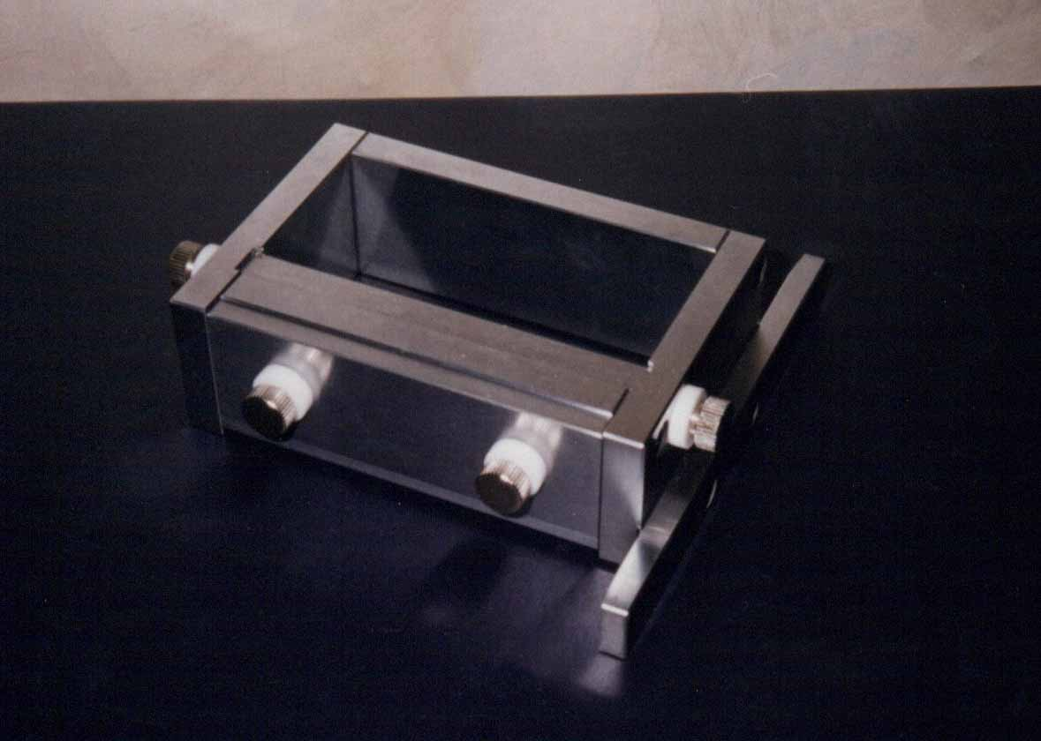

MANUFACTURER : U.S.A. Office :

HANSUNG SYSTEMS, INC. HANSUNG SYSTEMS USA, INC.
773, DAPSHIPRI 4-DONG, 22104, S.Vermont Ave. #106
DONGDAEMOON-GU, TORRANCE, CA. 90502-2156
SEOUL, KOREA. U. S. A.

PHONE : 82-2-2249-5235 PHONE : (310) 212-0707
FAX : 82-2-2249-2157
E-MAIL : ehansung@hotmail.com E-MAIL : ehansung@hotmail.com

* Above Specification will be changed without notice for machine improve .
CAT No. 020405

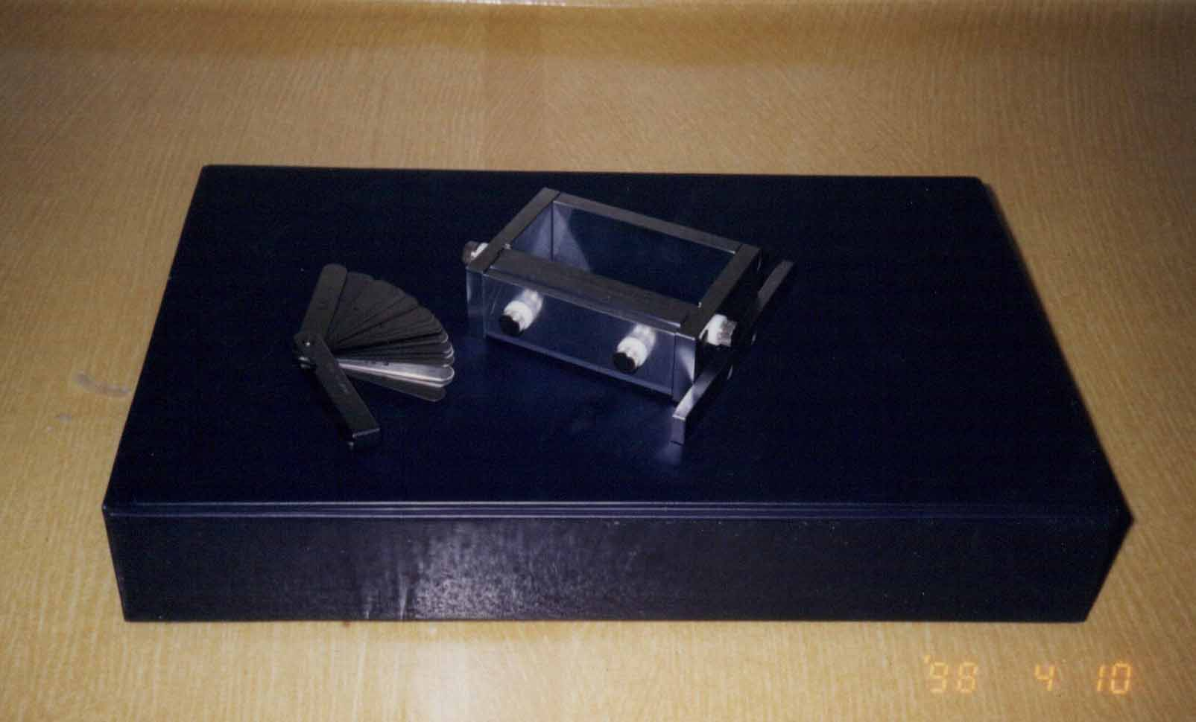

MANUAL (HAND) TAPE CASTING JIG (Model MTC-01A and

THICKNESS GAUGE

